

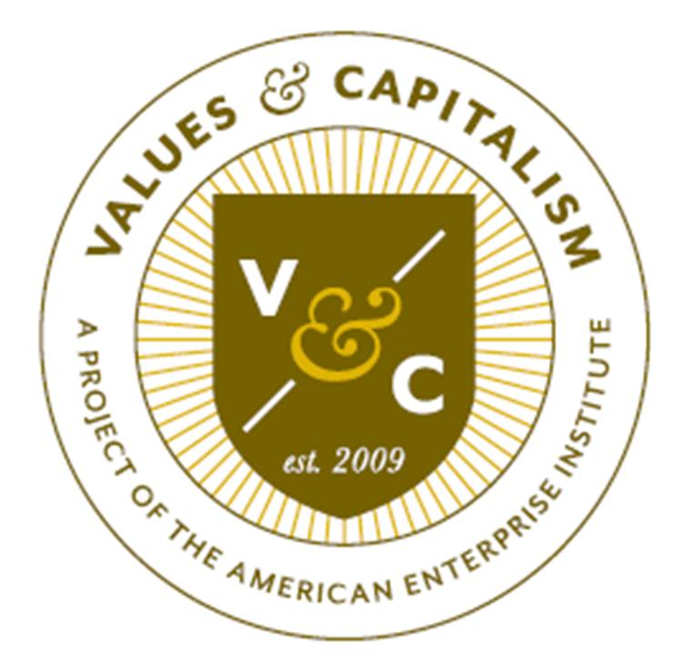

December 20, 2016

Dear Colleagues,

On behalf of the American Enterprise Institute’s Values & Capitalism project and Colorado Christian University, we would like to invite your team to attend the 2017 Values & Capitalism NPDA Invitational Tournament (Friday, February 3 – Saturday, February 4) to take place this year in our western “home” Denver, Colorado. Preliminary rounds will take place at CCU and the out-rounds are tentatively planned for historic sites in downtown Denver.

This unique tournament will draw upon AEI’s rich history of public policy analysis and will offer NPDA Novice and Open Divisions. The tournament begins at 11:00 am on Friday and will conclude with an awards ceremony at 4:00 pm on Saturday. In addition to the traditional judging pool, AEI scholars and staff members who will make the trek out to Denver, as well as local political professionals will also adjudicate some tournament rounds. These will be real-world analysts and policy-makers NOT typical tournament judges. Debaters and coaches will need to adjust as necessary. Tabulation will be conducted by experienced, college-level tournament directors.

There is no fee for participating and the Values & Capitalism project will provide meals and meal vouchers during the tournament, as well as partial travel vouchers for all teams based on distance from Denver. To register, please visit our tournament registration page on ForensicTournament.net or contact us at Tyler.Castle@aei.org or cleland@ccu.edu with your list of NPDA teams and judges, as well as any tournament questions you might have.

We hope that you will be able to join us in February.

With best wishes,

Tyler Castle Dr. Chris Leland
Program Manager Professor of Communication
Values & Capitalism Director of Debate
American Enterprise Institute Colorado Christian University

TOURNAMENT SPECIFICS

Event Rules: Debate will follow NPDA guidelines and rules (found at http://www.parlidebate.org/npda-rules/). Teams will be given 15 minutes of preparation time once the topic is announced. Team preparation space will be available in Leprino Hall, which will also have wireless internet access (login information provided at check-in).

Any regularly enrolled undergraduate in a two or four-year college is eligible to participate. The Novice Division is limited to those students in their first year of any type of debate. Anyone may enter the Open Division. Oral critiques at the end of each round should be kept to a minimum, instructional in nature, and constructive. Disclosure is at the discretion of the judges.

Topics: The tournament will focus on topics that are central to AEI’s Values & Capitalism project, including: free market economics, anti-poverty policy, financial policy, and education policy. Each round will focus on one of these policy areas. Topics will be formulated to allow for broad thinking and full engagement with the topic areas.

Awards: Awards will be given to the top five speakers in each division, as well as to each team who advances to out-round competition. Overall team sweepstakes awards will be given to the top three schools. Sweepstakes will be calculated using 3 points for each win in preliminary rounds and 5 points for each win in out-rounds for up to three teams per division.

VENUES

The tournament will take place at the on the campus of CCU (Lakewood, Colorado) and in downtown Denver. The Friday evening dinner will take place at CCU.

MEALS

AEI will host a dinner program, featuring a speaker from our scholar community on Friday (February 3), and will provide lunch during registration on Friday (February 3) and lunch on Saturday (February 4). Please let us know when registering if any of your team members require a vegetarian meals or special dietary needs.

TRAVEL TO DENVER, COLORADO

Denver International Airport is the closest airport and is about a 45 minute drive to the Lakewood area and the tournament hotel. The Hampton Inn is at 137 N. Union Blvd. Lakewood, Colorado and will serve as our tournament hotel. There is an agreed upon rate of $84 per room/quad occupancy/per night. Please mention the tournament when reserving.

AEI will offer partial travel vouchers for teams based on distance from Denver.

Location | Travel Voucher | Meal Voucher | Total
Within 400 miles of Denver | $100 per team | $60 per team | $160 per team
More than 400 miles from Denver | $300 per team | $60 per team | $360 per team

To receive the vouchers, coaches must complete and submit a check requisition form and a W9 form at the tournament or within four weeks of the tournament’s conclusion.

LODGING

The Hampton Inn located in Lakewood on Union Blvd is the tournament hotel. Again the address is 137 N. Union Blvd – Lakewood, CO – the number is (303) 969-9900. If there are questions please ask for Ashlee.

There are several other hotels in that area as well.

METRO RAIL SYSTEM

There is a new light rail system that takes passengers from DIA to downtown and out as far as Lakewood. The tournament hotel does not provide shuttle service from the airport but is about five blocks from the light rail stop.

CCU will be providing complimentary shuttle service for teams to/from the hotel to CCU if needed.

SCHEDULE OF EVENTS

Friday, February 3

11:00 am: Registration, Leprino Hall Lobby – CCU Campus
(Lunch provided from 11:15-12:00 noon)

12:00 pm: Topic Announce - Round 1
12:15 pm: Round 1

2:00 pm: Topic Announce - Round 2
2:15 pm: Round 2

3:30 pm: Topic Announce - Round 3
3:45 pm: Round 3

5:00 pm: Topic Announce - Round 4
5:15 pm: Round 4

6:30 pm: Dinner (provided), AEI

Saturday, February 4

8:00 am: Topic Announce – Round 5
8:15 am: Round 5

10:00 am: Topic Announce First Elimination Rounds
10:15 am: First Elimination Rounds

11:30 - Awards

12:00 pm: Topic Announce Second Elimination Rounds
12:15 pm: Second Elimination Round

1:30 pm: Lunch

2:00 pm: Final Round Topic Announce
2:15 pm: Final Round

